**UNEMPLOYMENT STATISTICS**

* In this report I used Long-Term-Unemployment-U.S. Dataset for year 2005 to 2015

Line Chart :-

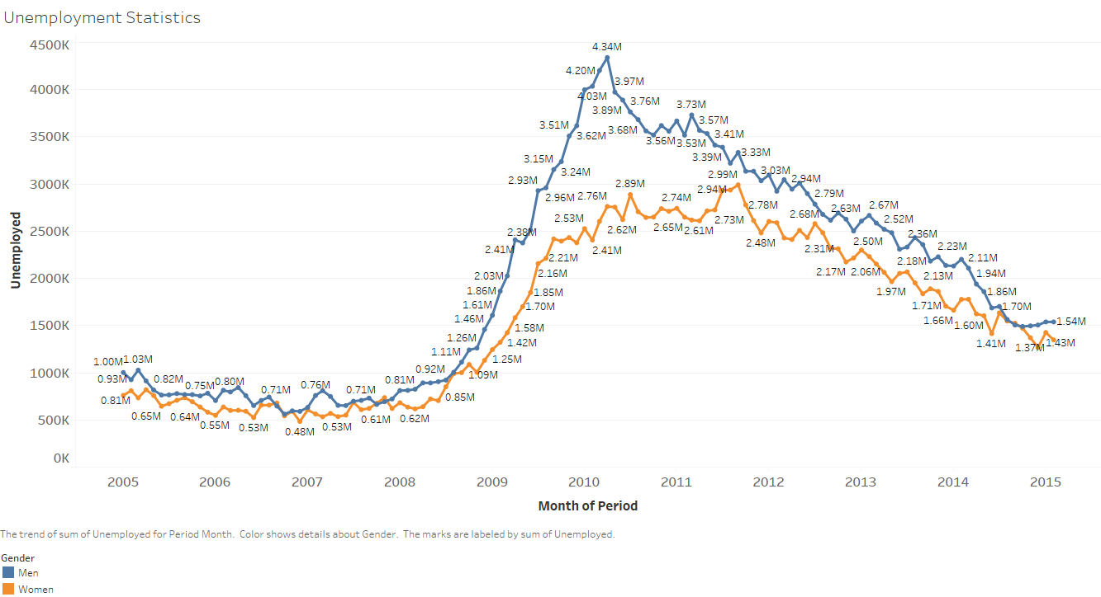

* From this chart we can clearly visualise that men are much more unemployed than women.
* For men highest unempolyment was 4.34M men in April 2010
* For women highest unemployment was 2.99M women in September 2011

Area Chart:-

Unemployment Chart For Women

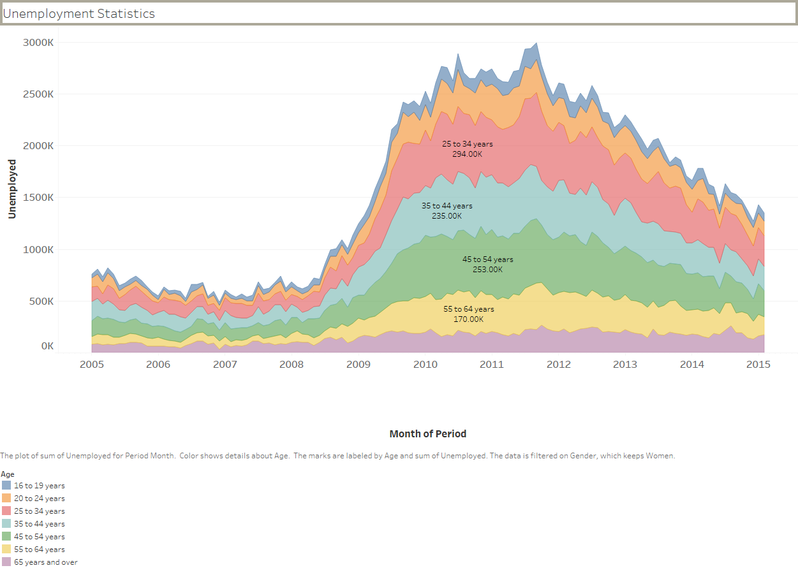

* This Area chart represent unemployment rate for women for different Age range.
* We can see that the unemployment for 25 to 34 years old women was 713 K in September 2011 and it was maximum unemployment for women for any age range and for any year.

Unemployment Chart For Men

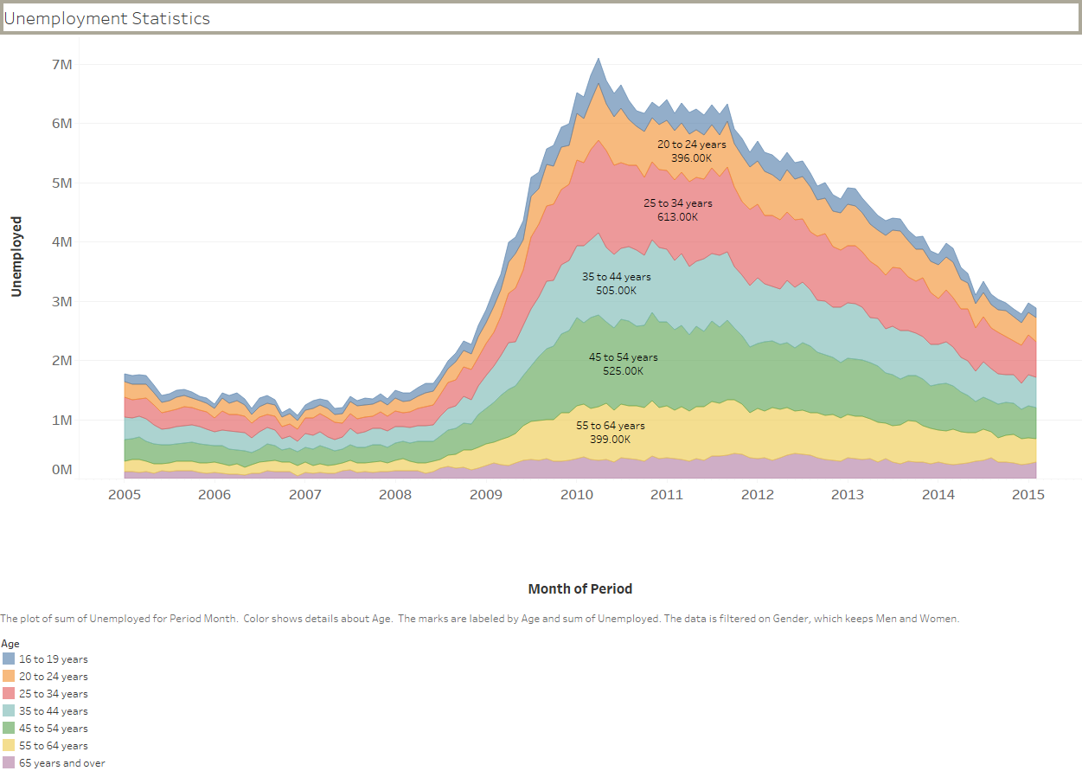

* This Area chart represent unemployment for men for different Age range.
* We can see that the unemployment for 25 to 34 years old men was 1642 K in May 2010 and it was maximum unemployment for men for any age range and for any year.

Unemployment Chart For Men & Women

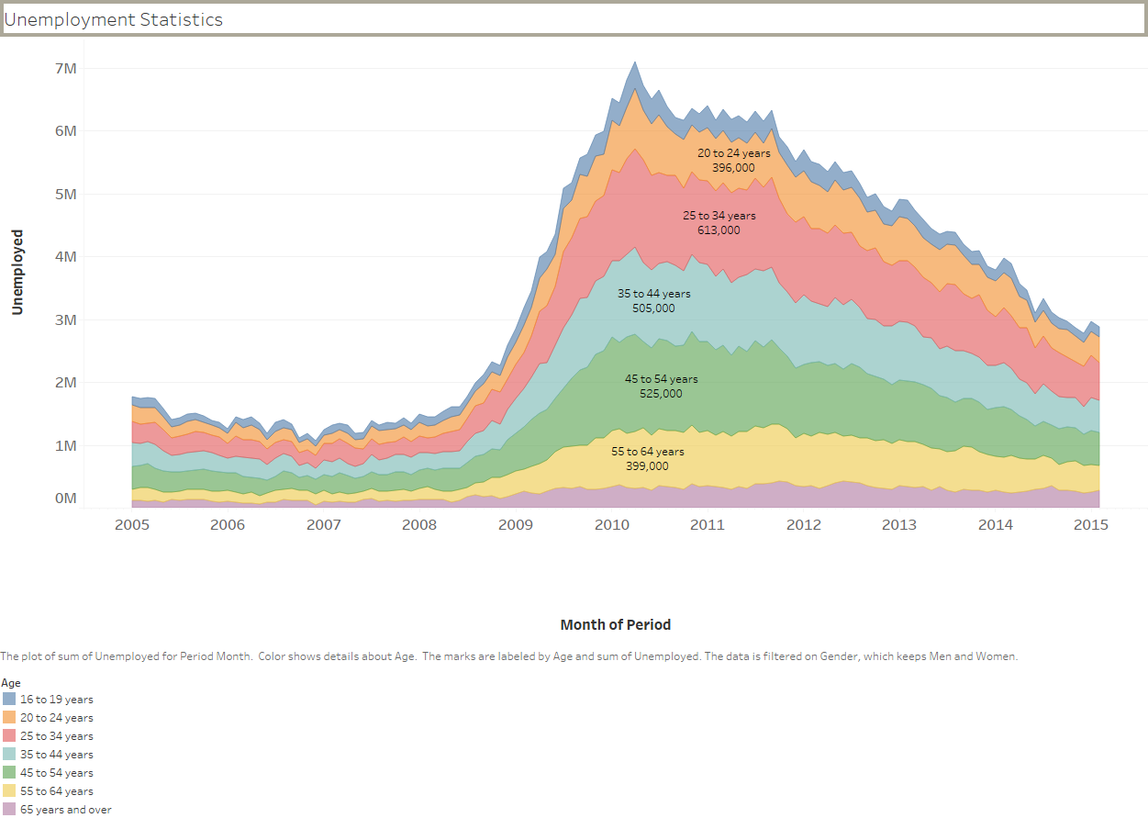

* We can see that for 25 to 34 years old men and women was highly unemployed for most of the year
* Highest unemployed people year was 2010 and it’s approximately 7.10 M people.